Project Design Phase-II
Data Flow Diagram & User Stories

Date | 28 June 2025
Team ID
Project Name | ShopEZ-E-Commerce Application
Maximum Marks | 4 Marks

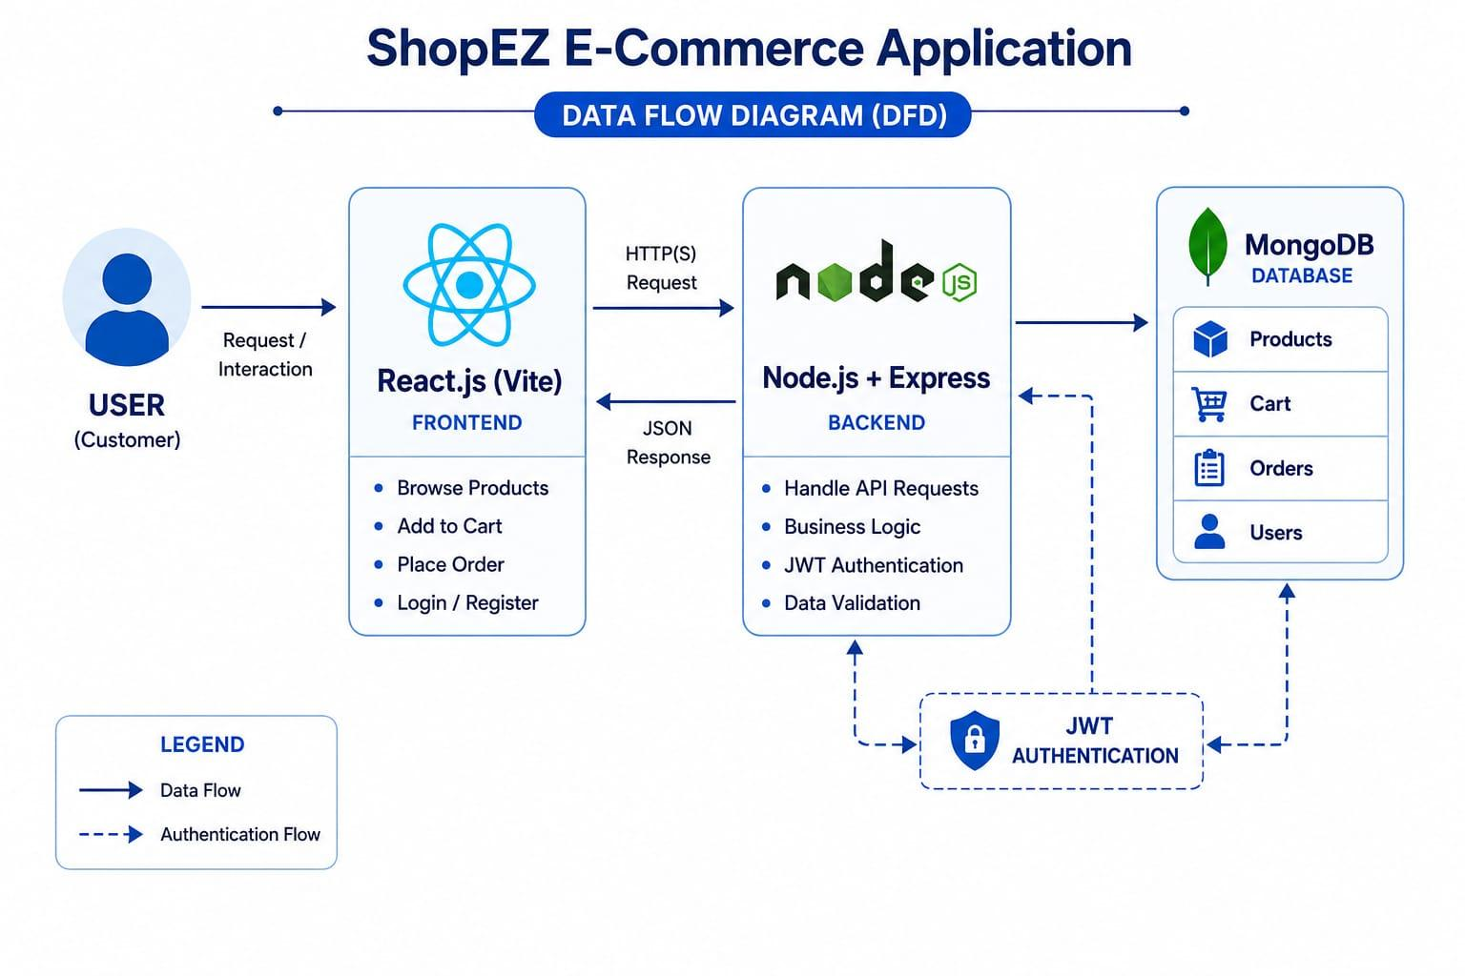

User Stories
User Type | Functional Requirement (Epic) | User Story Number | User Story / Task | Acceptance criteria | Priority | Release
Customer (Web user) | Registration | USN-1 | As a user, I can register by entering my name, email, and password. | User account is created successfully. | High | Sprint-1
Customer (Web user) | Login | USN-2 | As a user, I can log in using my registered email and password. | User is redirected to the Home page after successful login. | High | Sprint-1
Customer (Web user) | Product Listing | USN-3 | As a user, I can browse all available products. | Product list is displayed correctly. | High | Sprint-2
Customer (Web user) | Shopping Cart | USN-4 | As a user, I can add products to my shopping cart | Selected product appears in the shopping cart. | High | Sprint-2
Customer (Web user) | Shopping Cart | USN-5 | As a user, I can update or remove products from my shopping cart. | Cart is Updated successfully. | High | Sprint-2
Customer (Web user) | Order Placement | USN-6 | As a user, I can place an order for the selected products | Order is Updated successfully | High | Sprint-3
Customer (Web user) | About Page | USN-7 | As a user, I can view the About page of ShopEZ. | About page loads successfully | Medium | Sprint-3
Customer (Web user) | Logout | USN-8 | As a user, I can securely log out of the application | User session ends successfully | High | Sprint-3
Administrator | Product Management | USN-9 | As an administrator, I can manage products in the application | Products can be added, updated, and removed successfully. | Medium | Future Enhancement
Administrator | User Management | USN-10 | As an administrator, I can manage user accounts | User information can be viewed and managed successfully. | Medium | Future Enhancement

